Report from the village hall
The village hall AGM was held on Wednesday 29th June; the Trustees were delighted to welcome three new Trustees to the Village Hall management committee which now stands as:
Jenny Cameron, Chairperson; Gill Hollick, Secretary; Judith Knott, Treasurer; Rvd. Gary Crellin; Roy Hollick; Andrea Candlish; Heather Clarke; and Phil Thomas;
The meeting reported on the successes of the previous year which included the success of several grant applications, the installation of a stair lift and the purchase of some new tables and chairs. There had been several successful fundraising events since September, most notably the Christmas Fayre, the village quiz and afternoon teas.
In May the Trustees supported the Parish Council by providing refreshments at the well attended defibrillator training led by the registered charity Heartstart.
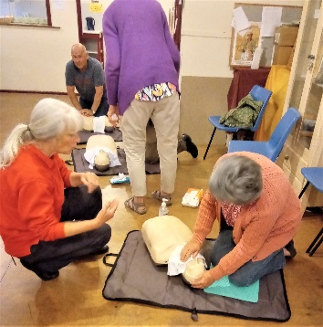
The highlight of the year so far had been the village celebrations for The Queen’s Platinum Jubilee. This was organised jointly by the Parish Council and the Village Hall and saw 120 people from Guarlford and the surrounding area enjoy a ‘bring and share’ picnic in Penny Close. The road had been closed for the afternoon and decorated with bunting, flags and marquees. The afternoon was opened by Mike Huskinson, Parish Council chairman before everyone began their picnic at a very long table which had been erected on the grass the full length of Penny Close. There were games, quizzes and scavenger hunts as well as entertainment from local Morris dancing groups, Appleyard and SoXSighted, a visually impaired group who came along with one of their guide dogs. Raffle prizes had been donated by The Plough and Harrow and The Green Dragon as well as other residents. The rain held off for the afternoon and everyone agreed that it had been a wonderful opportunity to celebrate with friends old and new
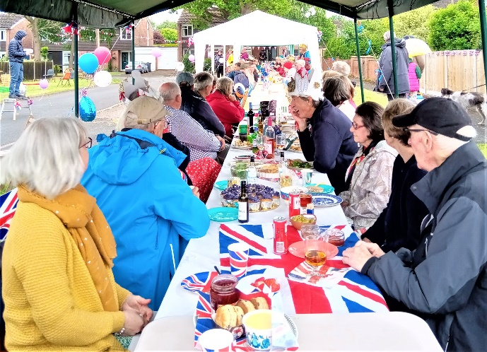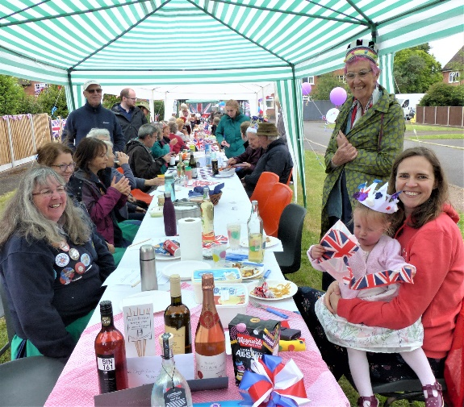

The Trustees voted to continue with their fundraising efforts through further grant applications and events in the Village Hall and agreed on a programme for the remainder of 2022
TARGET 150
Your village hall needs insulating, heating, new toilets and a new kitchen!
Help us reach our target of £150,000
Why not join us for one or all of the events planned for this year

August 20th 10 am – 12 noon Coffee morning in the village hall- Free to attend
September 10th 11th, 13th, 14th & 15th, Open days for National Heritage week Both the hall
and St Mary’s church will be open, check website for times. Refreshments available in the hall – Free to attend
September 10th – 18th Scarecrow festival - Check website for details
October 15th Barn dance - tickets available from September
November 25th Christmas crafts workshop mince pies and mulled wine - tickets available from October
December 3rd Christmas Fayre - Free to attend

Email:- guarlfordvillagehall@gmail.com
website:-http://www.guarlfordparish.uk/hall_trustees.htm

